President's Message
Welcome to a new school year! This is always an exciting and busy time of year. New school supplies, clothes, teachers, new friends, and football, what's not to love? FAPE is beginning a new year with goals and plans for reaching out to new members and bringing new folks to the FAPE team. If you haven't joined yet, please consider it now!
The FAPE board held it's annual retreat in Gainesville this July and worked on the second year of our strategic plan. Our number one priority this year is to host another one day drive-in workshop. We are looking at several locations, but if you have any suggestions, please let us know. The second priority is to increase membership in the organization. Priorities 3-5 are to continue to improve the FAPE website, increase participation on the Regional Representative committee, and continue to pair new coordinators with veteran coordinators.
We encourage your suggestions and participation in any of these areas! Team spirit and effort give us power to accomplish those goals. So please, come join our team. There are many ways to help!! Let's all continue to dream big dreams and work together to make those dreams come true!
As you will see in this newsletter, FDOE is hosting the annual Fall Leadership in Orlando October 20-21. It is a great time to network and learn something new! We hope to see you there!
Have a successful new year!
Liz

Florida Department Of Education and Florida PTA Parent Involvement Award Winners

On July 12th, ten schools were recognized by the Florida Department of Education (FDOE) and the Florida Parent Teacher Association (PTA) for programs showing innovative family and community engagement initiatives. The schools were honored during the PTA's annual Leadership Conference in Tarpon Springs. Commissioner of Education Pam Stewart, Florida PTA President Eileen Segal, Bureau Chief of FDOE's Family and Community Outreach Angelia Rivers and FDOE's Director of Volunteer and Community Involvement Kelli Walker were on hand to present the awards.

"Schools are most successful when parents and families are a close part of their mission and their community," said Commissioner Stewart. "It is my honor to recognize these efforts and my hope that all schools continue to work closely with families to ensure the success of every child."

Each year the Parental Involvement Award recognizes exemplary family and community involvement programs from across the state that focus on welcoming all families into the local school system, providing effective communication, supporting student success, speaking up for every child, and promoting collaboration among all stakeholders.

Florida PTA President, Eileen Segal states, "Family engagement is paramount to our children's education. When parents are full partners in their children's education, statistics show that no matter what socio-economic level they are, the child tests better, will go on to post-secondary education and the morale of the school elevates. Florida PTA is proud of this outstanding program and is proud to recognize these winners!"

Parent Involvement Award Winners
Region I
Leon County
Hartsfield Elementary School
World Culture Fair

Leon County
Fort Braden School
Math-A-Phobia Hotline

Region II
Nassau County
Bryceville Elementary School
A STEM Parent Night

Columbia County
Lake City Middle School
Lake City Middle School Community Outreach Program

Region III
Volusia County
Westside Elementary School
Bingo for Books

Volusia County
Atlantic High School
Family Night

Region IV
Pasco County
Moon Lake Elementary School
Watch Dogs

Pinellas County
Countryside High School
Teen Dating 101

Region V
Palm Beach County
Wellington Elementary School
"Arrgh," Hunting for Literacy Treasure at the Wellington Public Library

Dade County
Leewood K-8 Center
Trunk-or-Treat

For more information about more Family and Community Outreach programs and to sign up for the Just for Parents newsletter, visit http://www.fldoe.org/family/
.

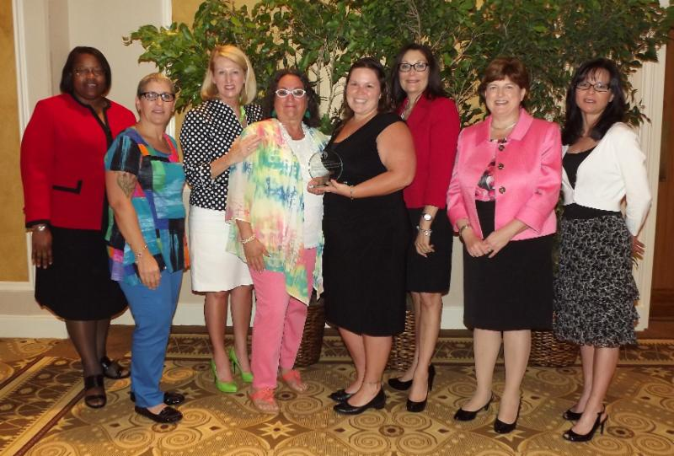
2014 Parent Involvement Award Winners

Rick Everitt Retires!

On July 13, 2014, FAPE presented a Lifetime Achievement Award to Mr. Rick Everitt. Rick has served Florida and Florida's children admirably throughout his career. This award was presented before Rick's peers at the 47th Annual PAEC Leadership Conference in Panama City. The following are the presentation remarks:
From Bonnet Pond, the Everitt family sent their young boy to Troy State. Football was the ticket! Football helped grow that young boy into a man who began a career in juvenile justice. After success int that endeavor he found his professional home--Education! For over 30 years, a unique individual has been standing tall in his role as son, husband, father, Papa, employee and friend. He has humbly stood in the face of crisis, disappointment, innovations that worked and some that didn't, and also in times of incredible joy and success. He has never been boastful nor seeking credit or honor for himself. His personal demeanor has always represented his inner values. He is honest, genuine, and a man of his word. On behalf of all who have crossed his path and for those who will reap the influence of his footprint, it is the FAPE board's honor to present this lifetime achievement award to a man who continues to stand tall, Rick Everitt!
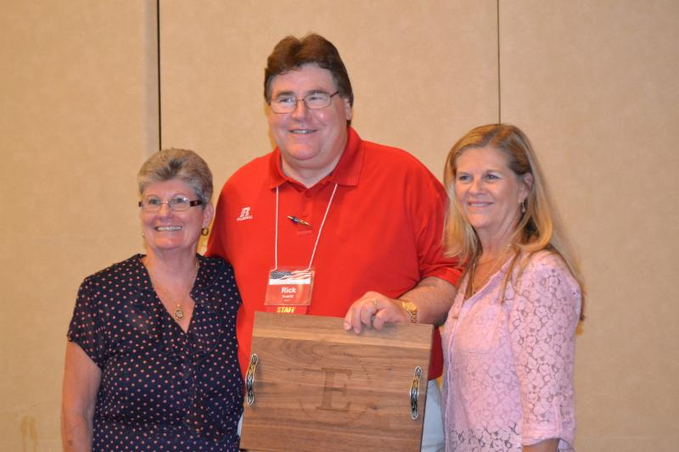
Rick Everitt accepting his award from FAPE Board
Alliance For Family Engagement Conference
Submitted by Michelle Roberge
Hooked on Family Engagement To Increase Student Achievement!
A Conference for Parents, All Grade Level Staff, Administrators, and Community Members
Friday, November 14, 2014
8:00 a.m.-3:30p.m.
Register now for this outstanding conference.
Select from 15 sessions to promote family engagement and to increase student achievement; network with colleagues; and visit the vendor walk.
Registration $65.00
(Includes continental breakfast, lunch, and door prizes!)
St. Petersburg Hilton Bayfront Hotel
333 1st Street South, St. Petersburg 33701
Parking $5.00
For more information call 727-588-5050.

